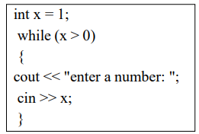Lab Task Lab Manual 5  
Muhammad Azfar Bin Nadeem  
Section C | 459000  
  
Q1) Convert the following while loop to a

do-while loop.   
  
  
  
  
Code  
  
Output

Q2) Use a do while loop to make a simple calculator for two numbers. Insert buttons for it to ask again and for termination.  
Code

Output  
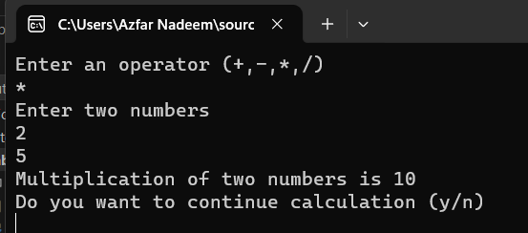

Q3) Write programs with while or do while loops that compute:

a. The sum of all even numbers between 2 and 100 (inclusive).  
Code  
Output  
  
b. The sum of all squares between 1 and 100 (inclusive).  
Code  
Output  


Q4) Write programs with while or do while loops that compute:  
a. All powers of 2 from 20 up to 220.  
Code  
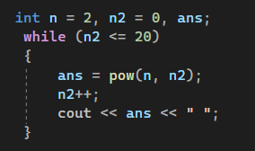  
Output  
  
b. The sum of all odd numbers between a and b (inclusive).  
Code  
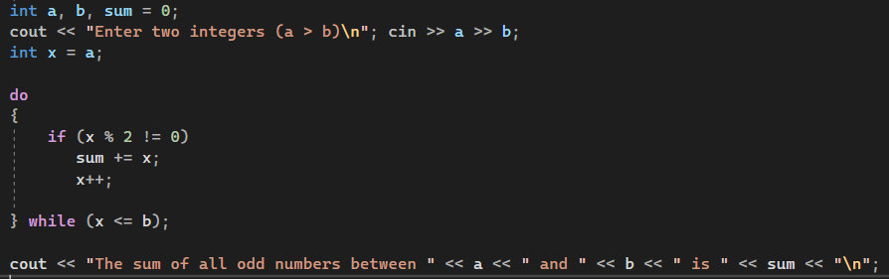  
Output  
